SCHOOL MANAGEMENT SYSTEM
THEME
We are modeling a school database to track student performance.
MODULES
- Students: Stores student personal details.
- Subjects: Stores the list of subjects (Mathematics, Science, Hindi, etc.).
- Exams: Stores details about specific exam events (e.g., Half-Yearly 2024).
- Marks: The transaction table linking students, subjects, and exams with a score.

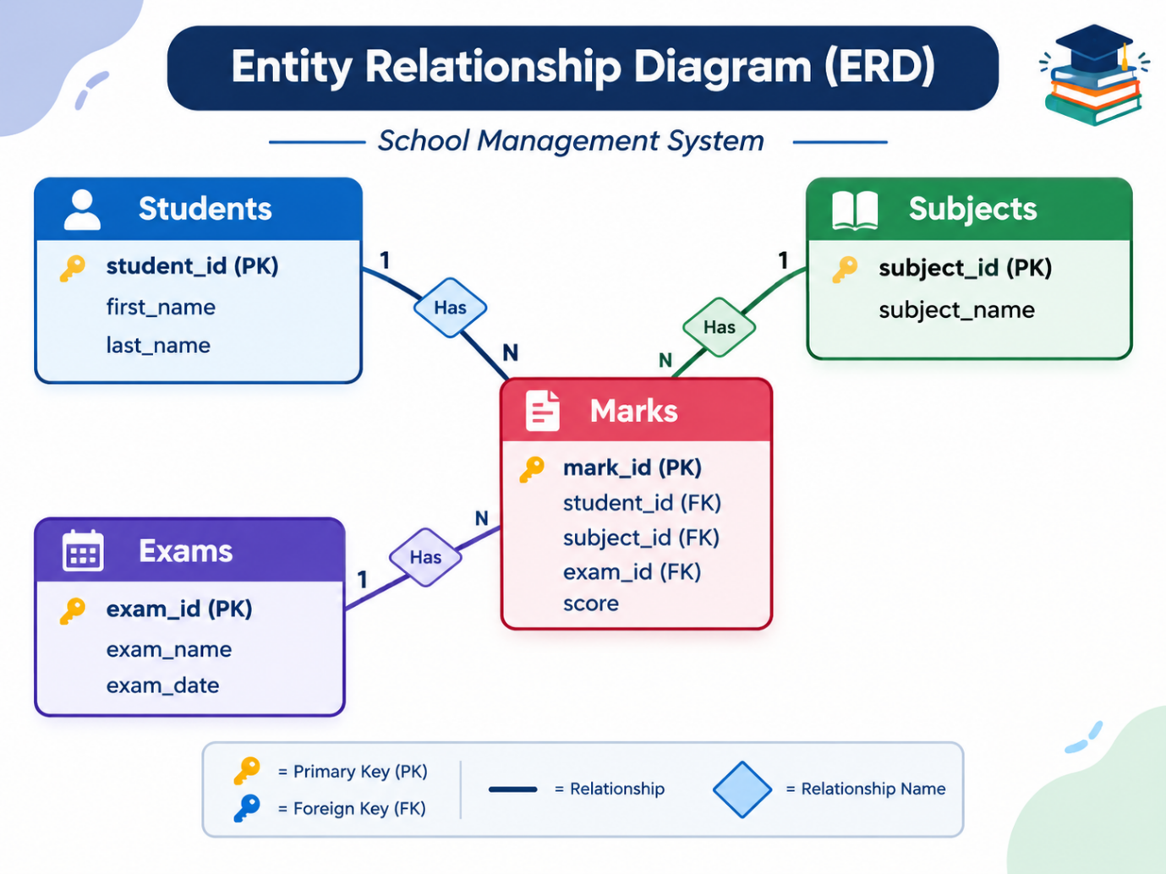

SAMPLE DATA:
STUDENTS:
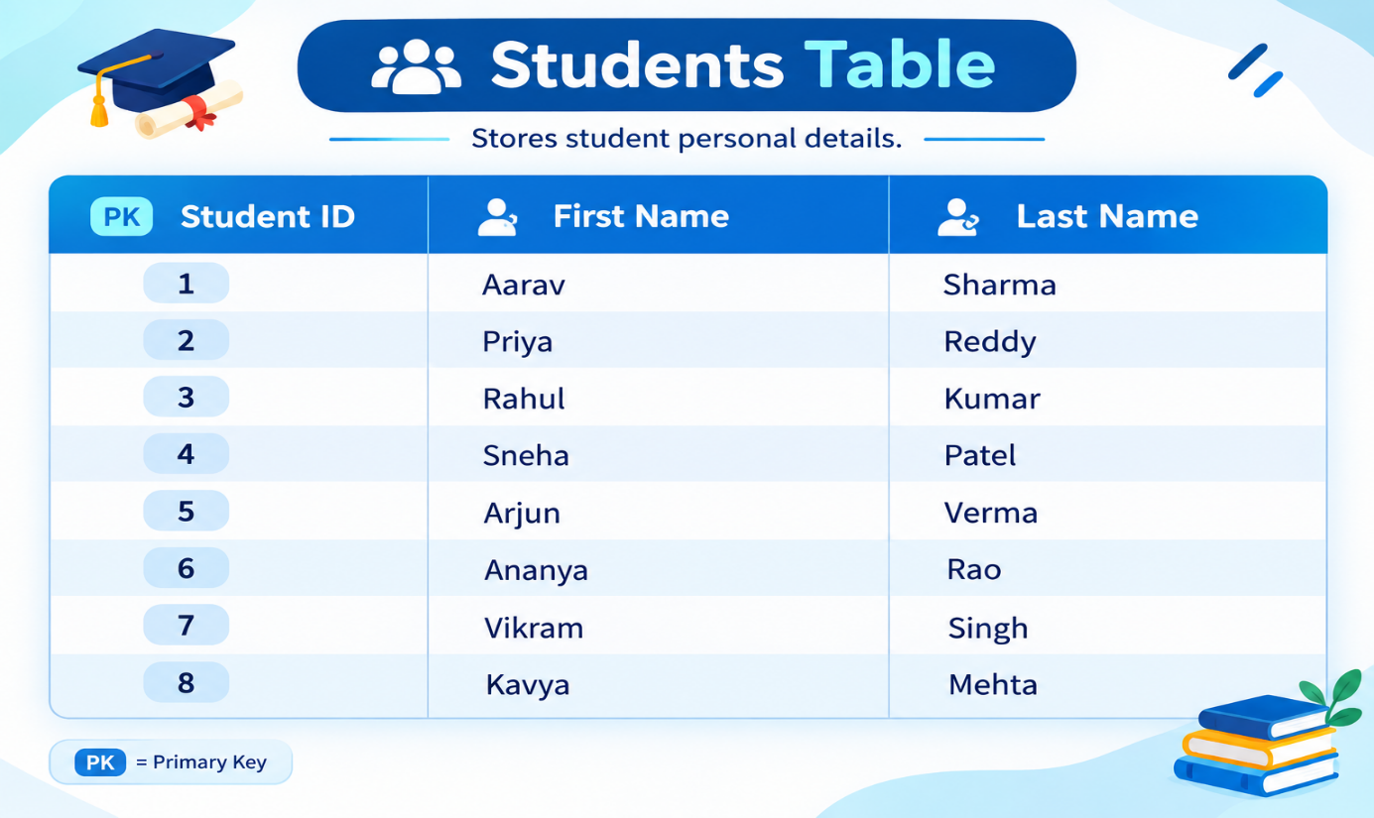
MARKS:
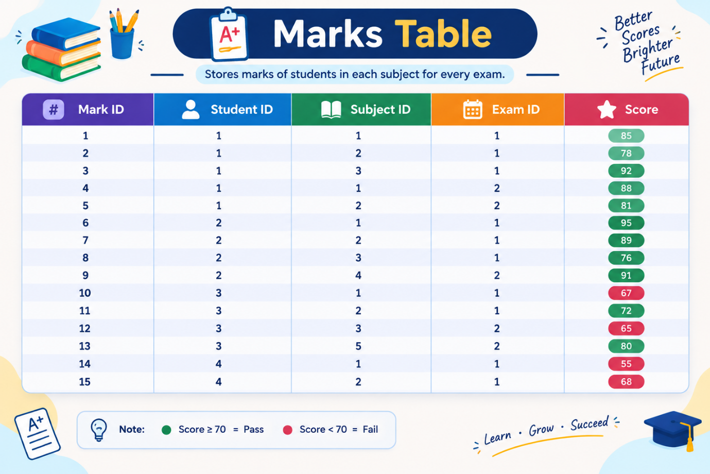
EXAMS:
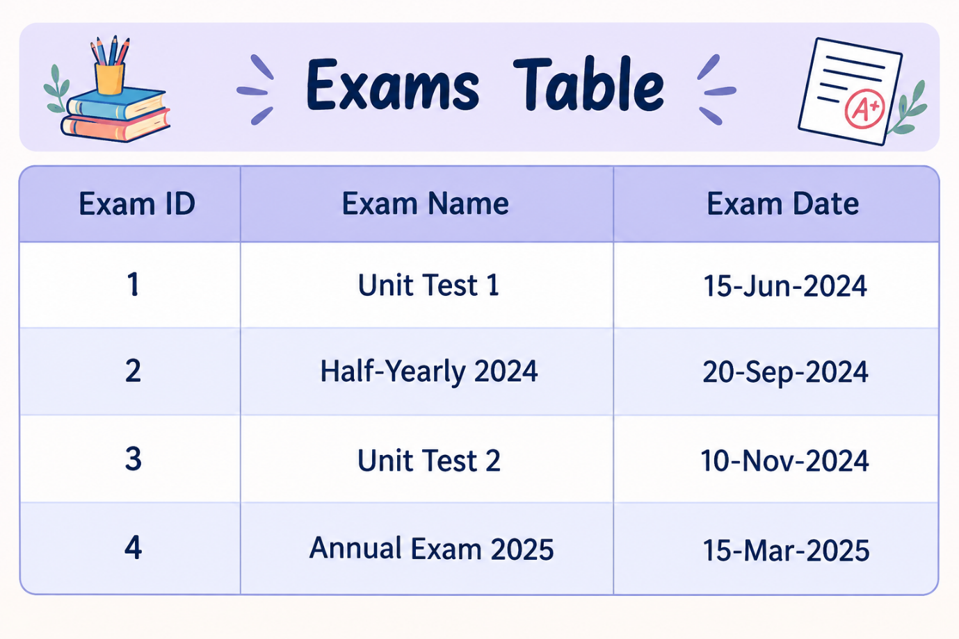
SUBJECTS:
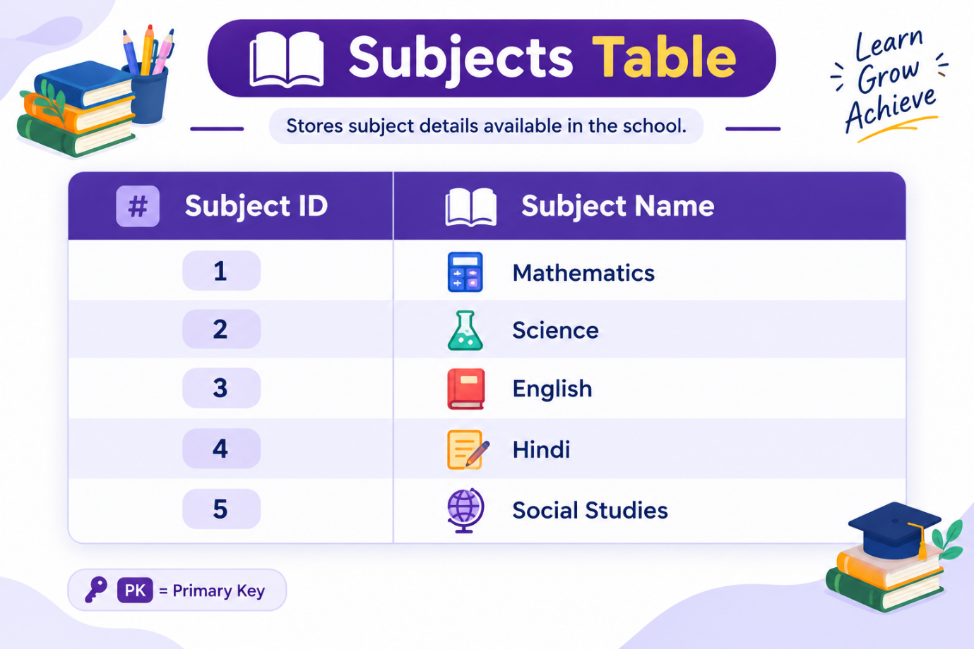
QUERIES:
Level 1: Simple (Basic Selection & Filtering)
- Retrieve all students: List the first name and last name of every student.
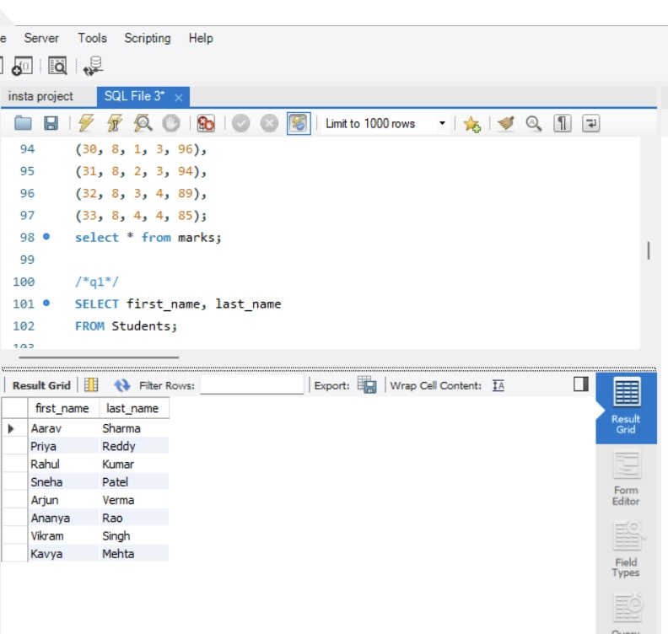
2. Filter by Score: Find all entries in the Marks table where the score is greater than 80.
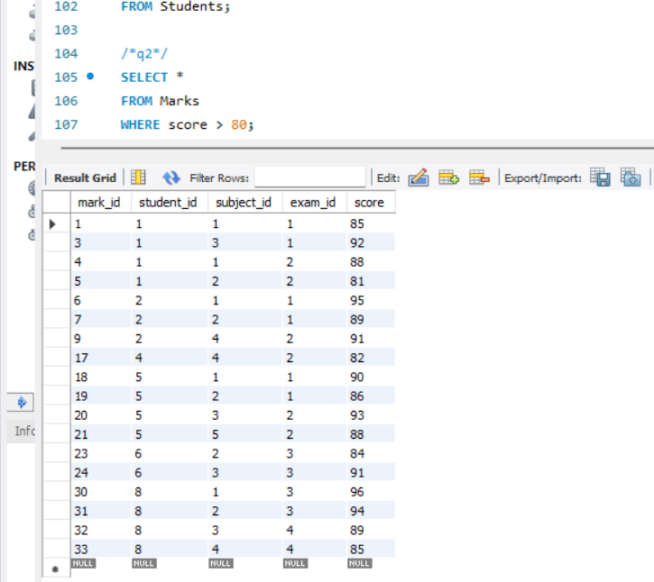
3. Sort Data: List all exams sorted by their date, starting with the most recent.
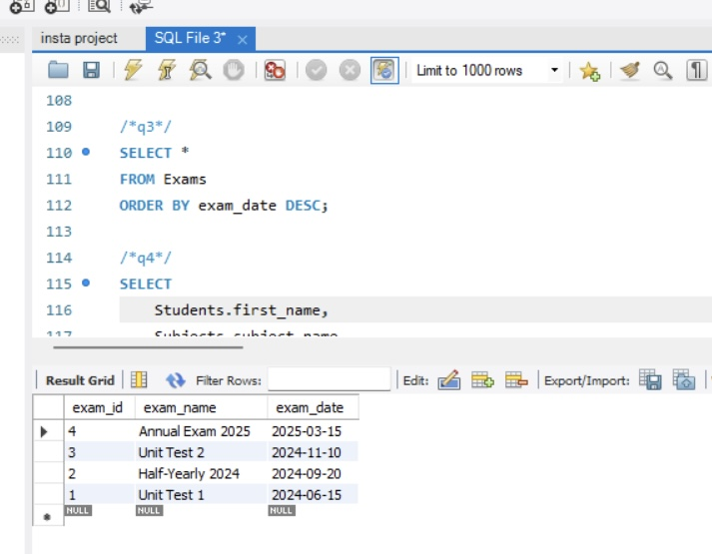
Level 2: Intermediate (Joins & Aggregation)
- Student Marks: List the First Name, Subject Name, and Score for every mark recorded. 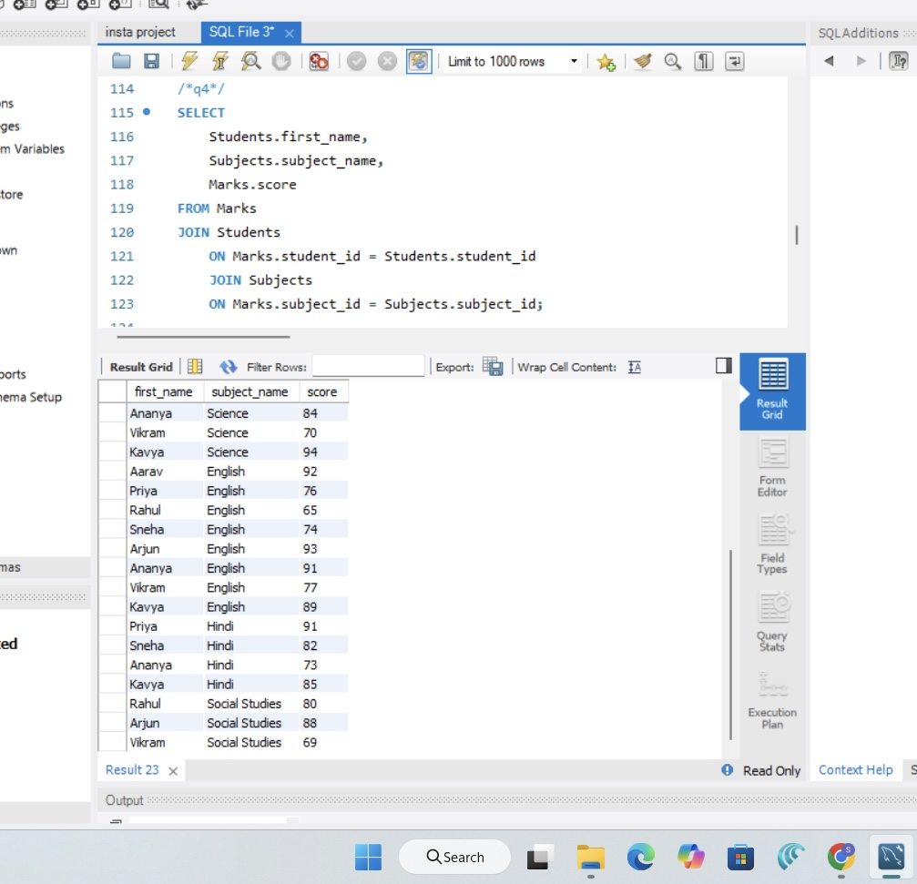
5. Subject Averages: Calculate the average score for each subject. Display the Subject Name and the Average Score.
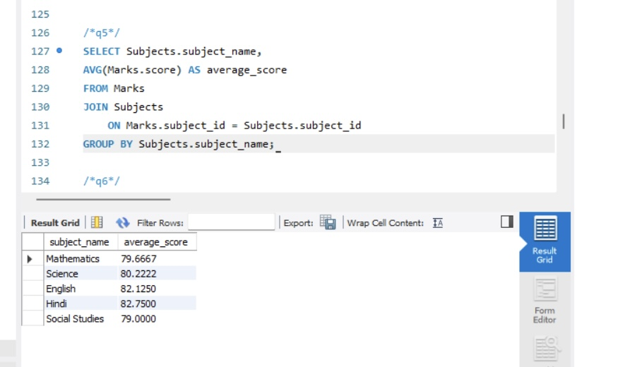

6. Count Exams: How many marks have been recorded specifically for "Aarav Sharma"?

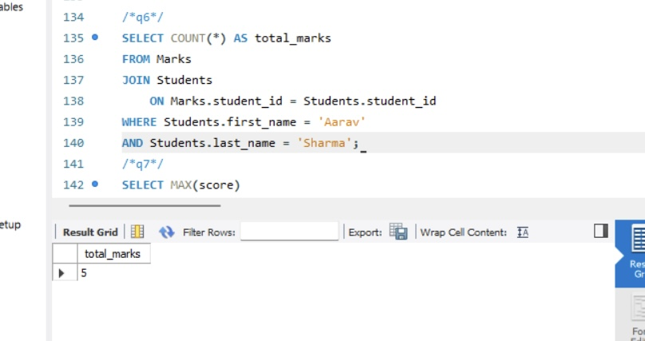

Level 3: Complex (Subqueries, Grouping & Logic)
- Top Performer: Find the student (First Name, Last Name) who has the highest single score in any exam.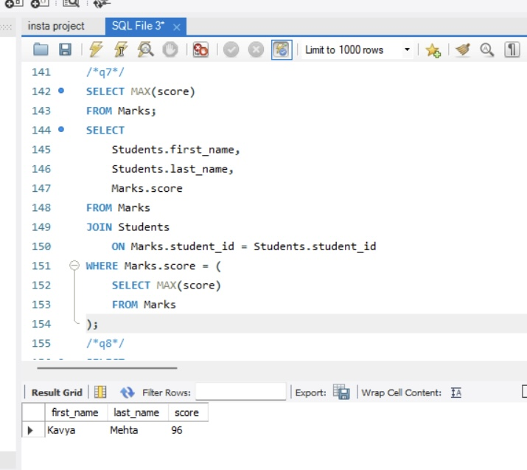

8. Scores by Exam: Display the Exam Name and the total sum of scores for that exam, but only for exams where the total sum is greater than 250.

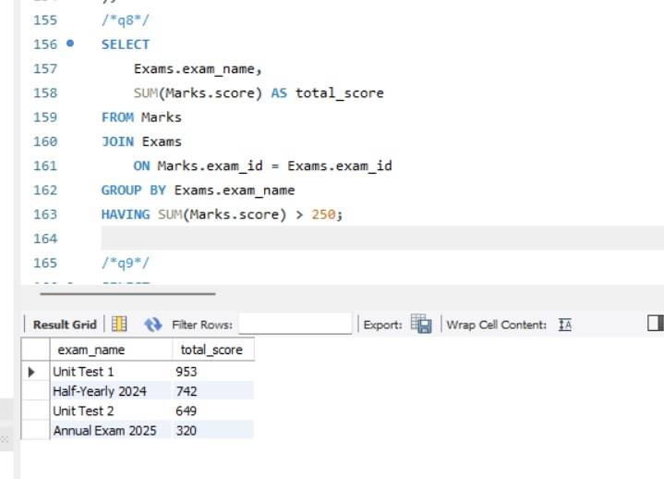
9. Pass/Fail Label: Create a report showing the Student Name, Subject, Score, and a status column that says "Pass" if the score is 70 or above, and "Fail" if below.
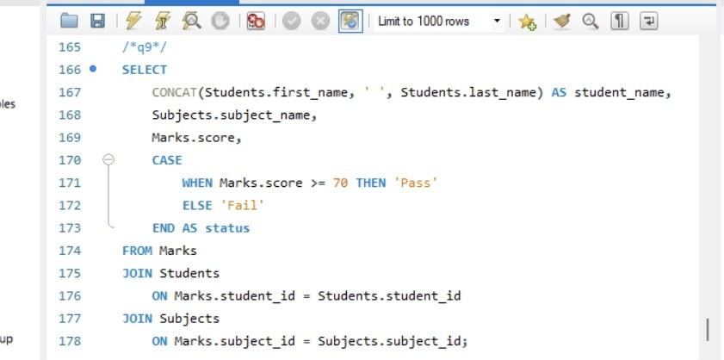

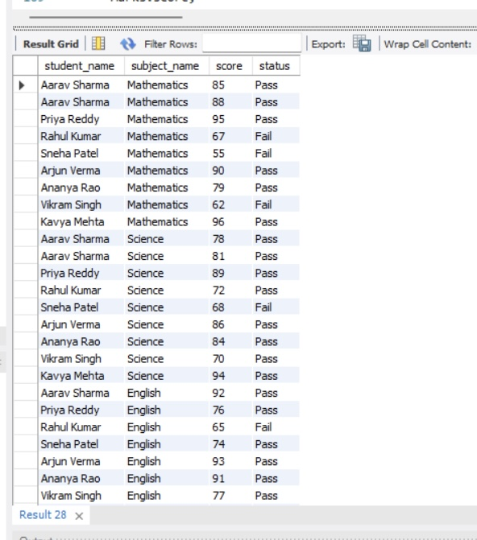

Prepared by K.Sanjana Reddy

